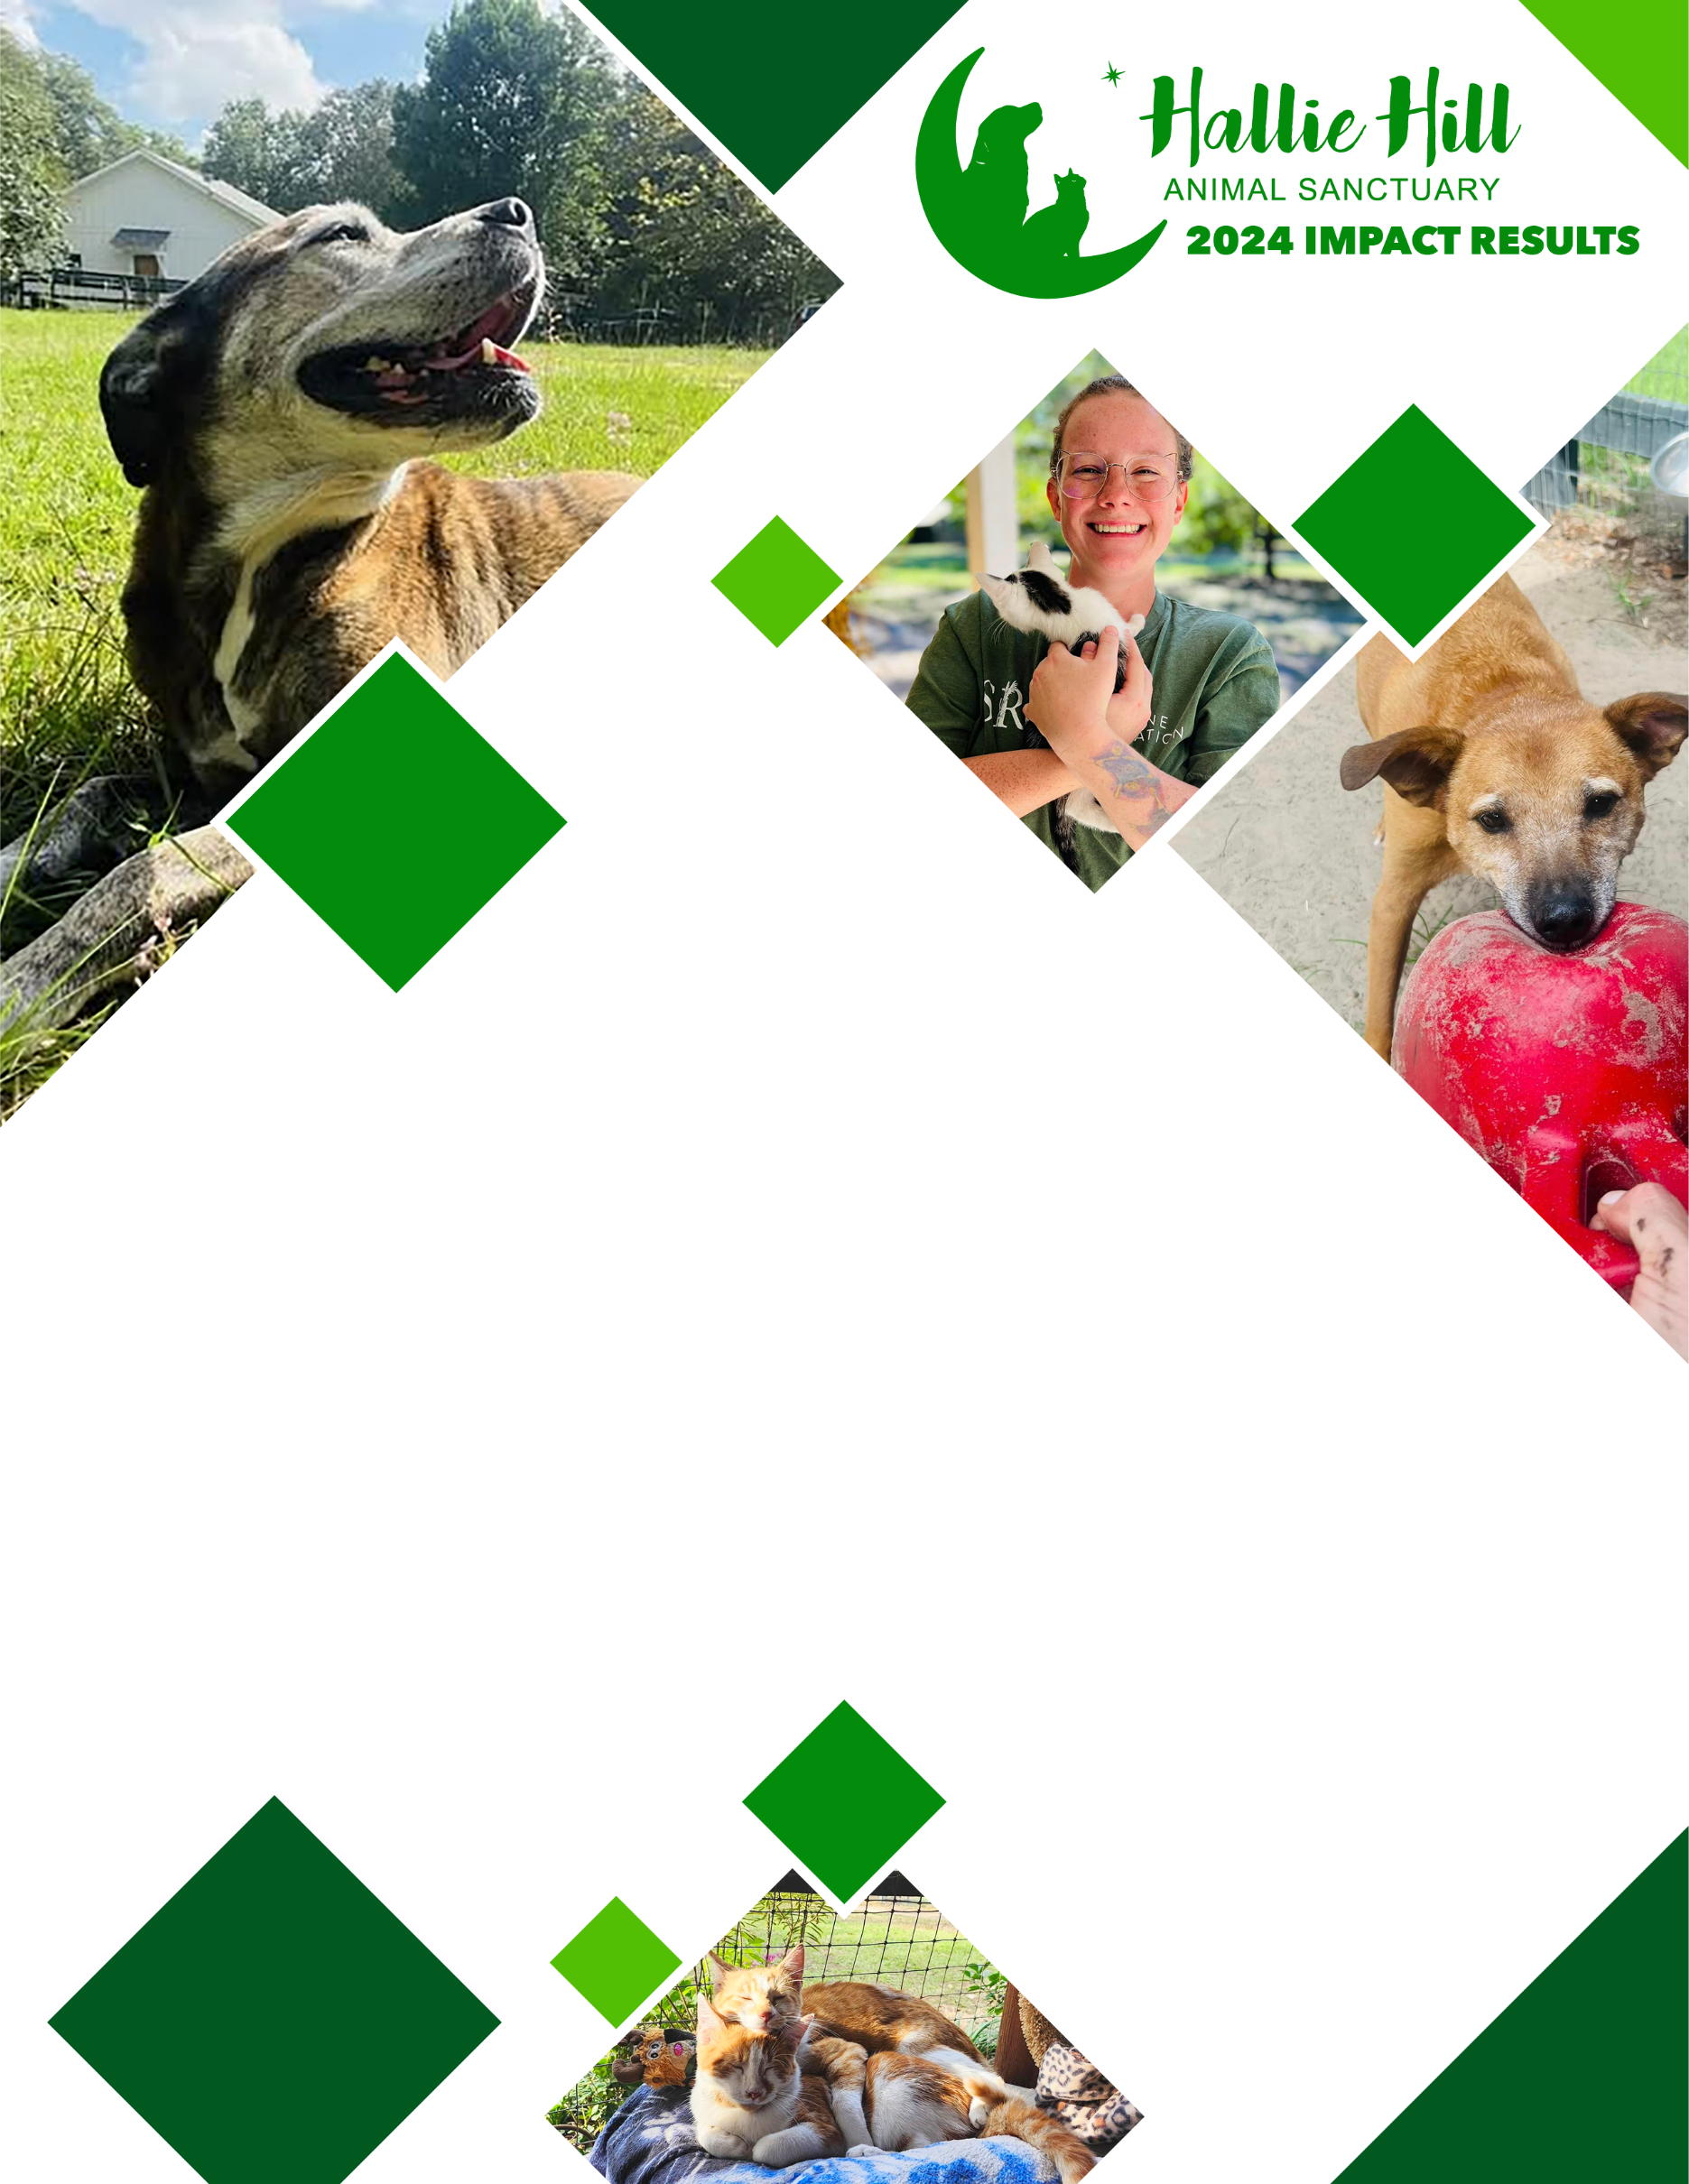

**While we can’t change an animal’s past, we can rewrite their future.**

**SERVING THE**

**COMMUNITY**

**PROVIDING SANCTUARY**

**PROVIDING NOURISHMENT**

Apportioned over **42,770** pounds of dog food and over **5868** pounds of cat food for animals onsite.

**SENIOR CARE**

Administered loving care to **152** senior animals with special needs associated with their advanced years.

**SAFE HAVEN FOR STRAYS**

Cared for **29** animals brought in by the public as strays.

**BARN CAT SANCTUARY**

Provided an onsite safe-haven for over **30** community cats. While we can’t change an animal’s past, we can rewrite their future.

**EDUCATION**

Presented educational pieces on more than **50** television and web-based program appearances in the greater Charleston area. Appearances focused on highlighting adoptable pets, pet safety and best practices for responsible pet ownership.

**HELPING FAMILIES**

Accepted **70** animals at no charge from families unable to care for their pets.

**COMMUNITY EVENTS & OUTREACH**

Held off-site adoption events in conjunction with area veterinary service providers and made multiple appearances at schools and community groups. Again hosted Animals, Arts and Automobiles, an annual event that brings more than **350** people out to support our work.

**ASSISTING SHELTERS**

Accepted **68** animals from overcrowded local shelters.

**VOLUNTEER INVOLVEMENT**

Partnered with businesses, private individuals and schools who donated over **7275** hours of time.

**PET ADOPTIONS**

Placed **117** animals into loving homes while offering pre and post adoption counseling and resources to help make placements successful.

**DISEASE & PARASITE PREVENTION**

Administered vaccinations to **184** animals preventing deadly diseases like rabies and administered heartworm and flea prevention to **386** animals.

**END OF LIFE CARE**

Provided respectful and loving care to help transition **15** animals through the end-of-life process.