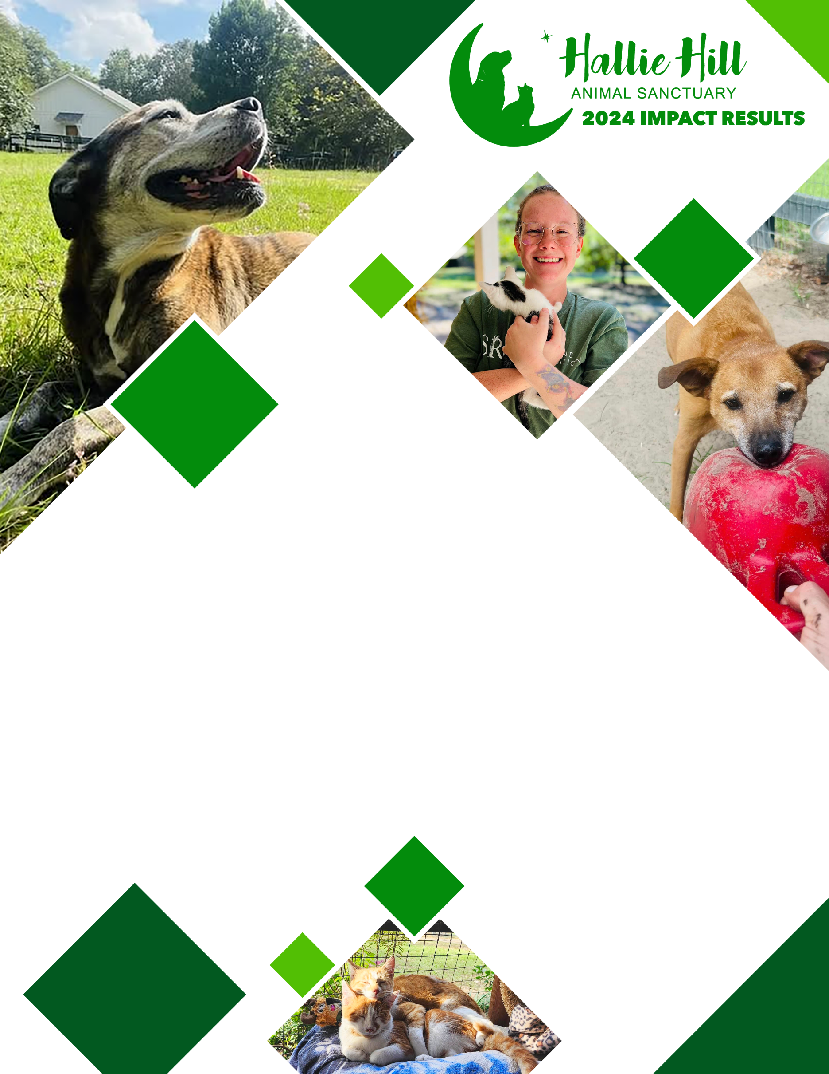
While we can’t change an animal’s past, we can rewrite their future.
SERVING THE
COMMUNITY
PROVIDING SANCTUARY
PROVIDING NOURISHMENT
Apportioned over 42,770 pounds of dog food and over 5868 pounds of cat food for animals onsite.

SENIOR CARE
Administered loving care to 152 senior animals with special needs associated with their advanced years.

SAFE HAVEN FOR STRAYS
Cared for 29 animals brought in by the public as strays.

BARN CAT SANCTUARY
Provided an onsite safe-haven for over 30 community cats. While we can’t change an animal’s past, we can rewrite their future.
EDUCATION
Presented educational pieces on more than 50 television and web-based program appearances in the greater Charleston area. Appearances focused on highlighting adoptable pets, pet safety and best practices for responsible pet ownership.

HELPING FAMILIES
Accepted 70 animals at no charge from families unable to care for their pets.

COMMUNITY EVENTS & OUTREACH
Held off-site adoption events in conjunction with area veterinary service providers and made multiple appearances at schools and community groups. Again hosted Animals, Arts and Automobiles, an annual event that brings more than 350 people out to support our work.

ASSISTING SHELTERS
Accepted 68 animals from overcrowded local shelters.

VOLUNTEER INVOLVEMENT
Partnered with businesses, private individuals and schools who donated over 7275 hours of time.
PET ADOPTIONS
Placed 117 animals into loving homes while offering pre and post adoption counseling and resources to help make placements successful.

DISEASE & PARASITE PREVENTION
Administered vaccinations to 184 animals preventing deadly diseases like rabies and administered heartworm and flea prevention to 386 animals.

END OF LIFE CARE
Provided respectful and loving care to help transition 15 animals through the end-of-life process.

